**(20 points) int getFactorial(int val);**

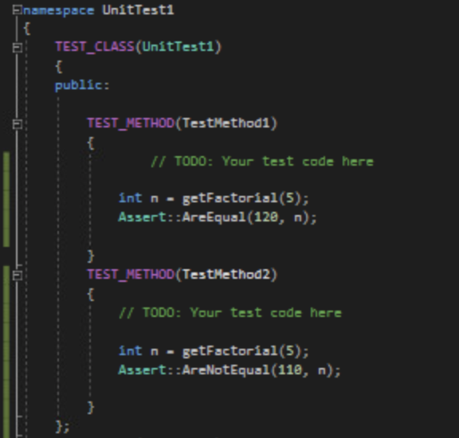

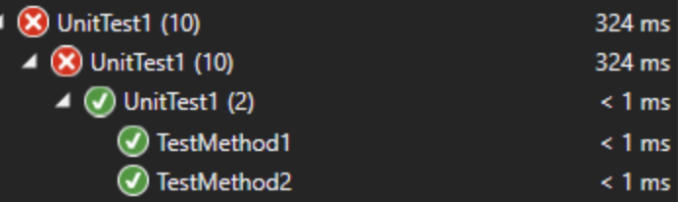

**(20 points) points int subArraySum(int a[], int n, int start);**

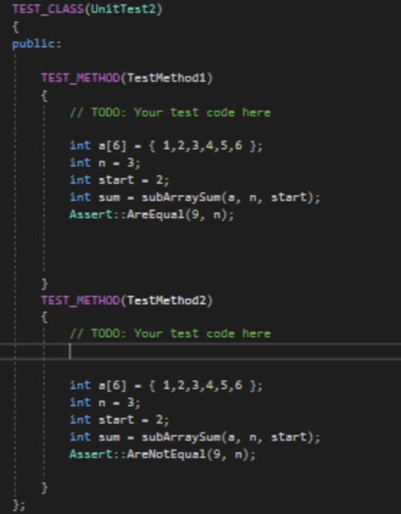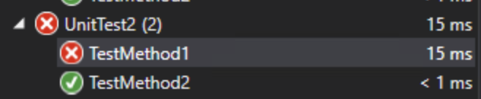

**(20 points) int check_anagram(char a[], char b[]);**

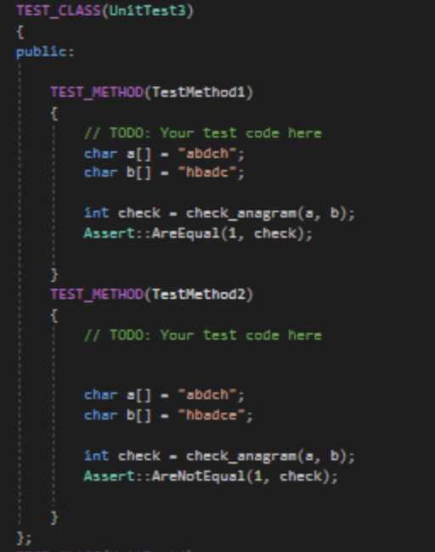

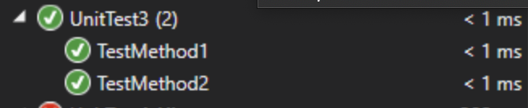

**(40 points) int getStrongNess(string& input);**

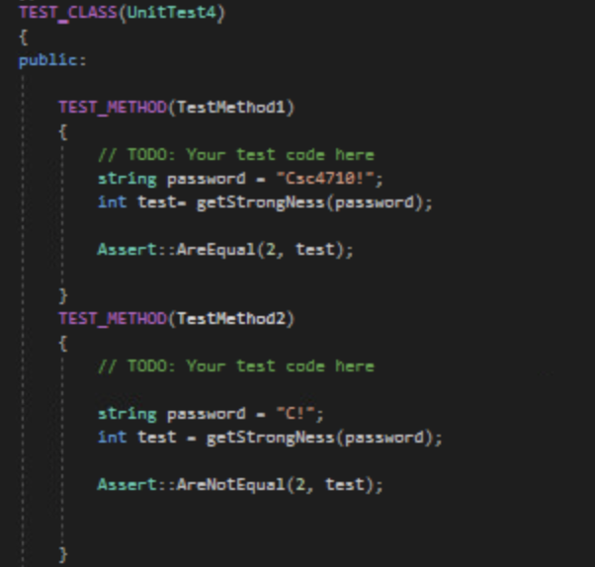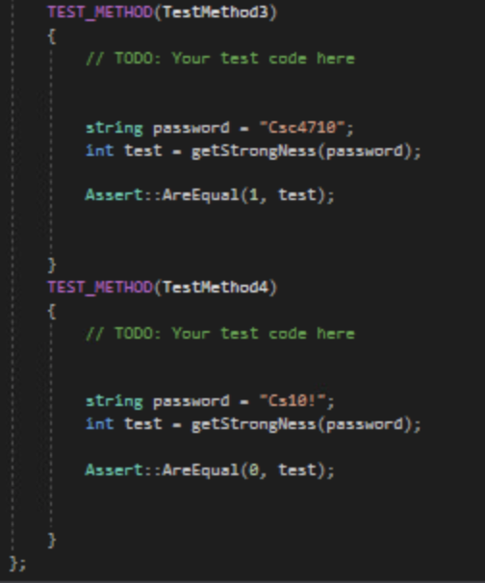



Deliverables:

1) Delete .db (.sdf), .suo and the debug folders from the project (make sure it keeps the code

of your unit tests).

2) Make screenshots of the testing results in Test Explorer after clicking Run All for each

method. Save those screenshots in a Word file FirstName_LastName_A7.docx.

3) Put your cleaned project and report in a zipped file FirstName_LastName_A7.zip and

submit it to Canvas.